Abstract title (16pt, bold, align left, only first letter capitalized)
I. M. Author^{1*}, A. D. Two², and M. T. Three³ (12pt, bold, align left)
¹Institution address; (10pt, italic, align left)
²Institution address (10pt, italic, align left)
³Institution address (10pt, italic, align left)
*Presenting author; E-mail: i.m.author@institution1.com
Introduction (11pt, bold, align left)
The total size of the abstract should not exceed 2 pages Abstract should be written in format A4, with the following margins: top 3.5 cm, bottom 2.5 cm, left and right – 2.75 cm, just like in this template. Body text should be written using the font Times New Roman, 10 pt, full justification.
Indents: none for first paragraph, 0.51 cm for other paragraphs, 0.51 cm hanging indent for references at end of paper. No spacing above or below the paragraphs.
This is a paragraph introducing an equation:
Na_{2.12}K_{1.06}Ca_{0.79}Mg_{0.79}Fe_{0.26}Al_{5.29}Si_{30.18}O₇₂.19.06H₂O (1)
This is the continuation of the equation-introducing paragraph. Notice that there is no line above and below the equation.
Experimental Methods (11pt, bold, align left)
Line spacing: single throughout the text. If using styles in the Word template, the line spacing is built in, so don’t add additional space after the title, author list, etc. However, do add space (10pt) above and below figures and tables.
Results and Discussion (11pt, bold, align left)
Tables, if desired: Use only horizontal rules: One at the top of the table, one separating the table header from the data, and one at the end of your table. Additional horizontal rules may be used in the table header for grouping columns with similar headings, but don't use them to separate individual rows. Table caption. 9 pt, align left, at top of table.
Empty raw before and after tables and figures.

Table 1. Example of table caption.

 | ZEN sorption index,%
 | OZ-2 |  |  | OZ-5 |  |  | OZ-10
Solid/liquid ratio  (mg/10 mL) | pH 3 | pH 7 | pH 9 | pH 3 | pH 7 | pH 9 | pH 3 | pH 7 | pH 9
40 | 86 | 93 | 96 | 93 | 99 | 99 | 96 | 99 | 99
20 | 72 | 79 | 87 | 88 | 96 | 99 | 91 | 97 | 98
10 | 56 | 66 | 68 | 79 | 82 | 90 | 78 | 88 | 92
4 | 34 | 37 | 33 | 59 | 52 | 60 | 56 | 65 | 80

Graphics Guidelines
Figures can be either black and white or 8-bit grayscale. Place figures where you want them in the text of your abstract. Reduce or enlarge the figure BEFORE inserting it into the document. The maximum width of a figure is 14 cm. After the figure is properly sized, ensure it is at one of the following resolutions:
line art: 600 dpi
grayscale and line art mixed: 600 dpi
grayscale only: 600 dpi
Preferred formats are TIFF with the same resolutions as listed above.

Figure caption. 9 point, align left, at bottom of figure.

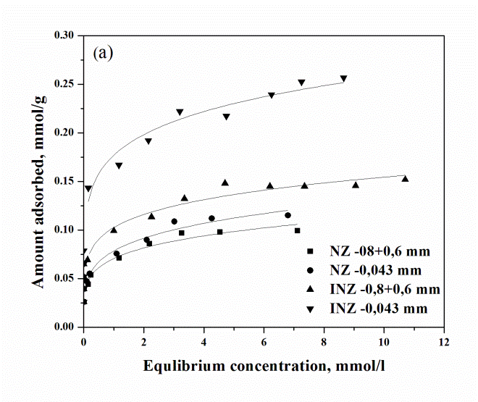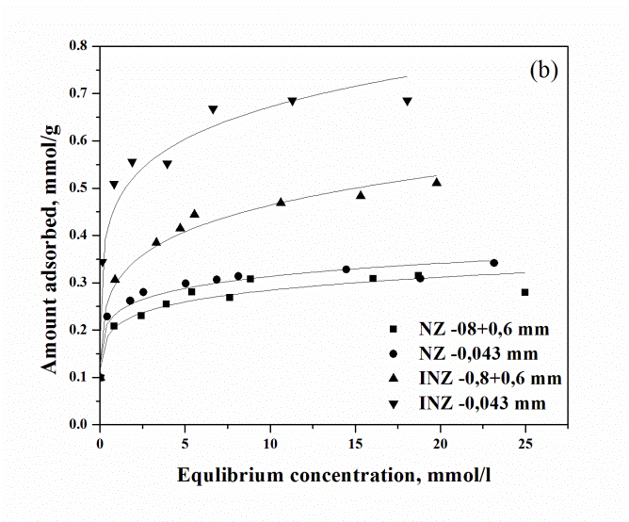
Figure 1. Example of (a) figure (b) caption.

Acknowledgment (10pt, bold, align left)
Indents: none for first paragraph, 0.51 cm for other paragraphs, 0.51 cm hanging indent for references at end of paper. No spacing above or below the paragraphs.
References (11pt, bold, align left)
References are cited in the text by the name of the author and the year of publication, e.g., Noh (1998) or Brandt and Kydd (1998). For references with more than two authors, use ‘‘et al." as in White et al. (1992). Citations in parentheses must include a comma, e.g., (White et al., 1992). Full references are listed alphabetically by author at the end of the paper and with the year in parentheses. For several publications of an author with different co-authors the following order must be followed: (a) publications of the author alone, in chronological order; (b) publications of the author with a single co-author, in alphabetical order of co-authors; (c) publications of the author with more than one co-author, in chronological order (as they are cited in the form ‘Jones et al.‘ in the text). The name of the author is given surname first, followed by a comma and the initials, with each initial followed by a period and without a space between initials. Do not abbreviate journal names. Volume numbers are in bold. For example:
Jahren, J.S. (1991) Evidence of Ostwald ripening related recrystallizations of chlorites from reservoir rocks offshore Norway. Clay Minerals, 26, 169–178.
Kalt, A. (1968) Une silice hydratée cristallisée: Préparation, structure, propriétés chimiques. Ph.D. thesis, Université de Strasbourg, Strasbourg, France, 197 pp.
Koizumi, M. and Roy, R. (1959) Synthetic montmorillonoids with variable exchange capacity. American Mineralogist, 44, 788–805.
Reynolds, R.C. (1980) Interstratified clay minerals. Pp. 249–303 in: Crystal Structures of Clay Minerals and Their X-ray Identification (G.W. Brindley and G. Brown, editors). Monograph 5, Mineralogical Society, London.
Weaver, C.E. and Pollard, L.D. (1973) The Chemistry of Clay Minerals. Elsevier, Amsterdam, 213 pp.

